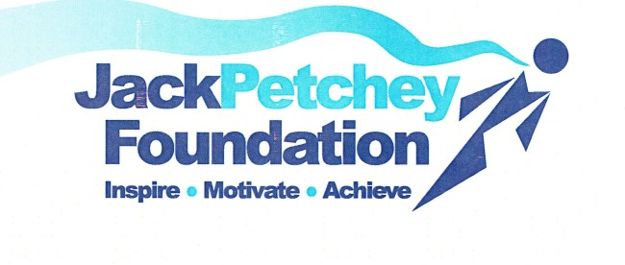

JACK PETCHEY ACHIEVEMENT AWARD SCHEME

Please nominate students for the current round of this prestigious award which recognises young people for what they do well! We want to acknowledge and celebrate young people for showing excellence in what they do and we are eagerly waiting for your nominations!

Nominations can come from students, teachers, parents/carers, support staff and trustees, so please do not hesitate!

The students you nominate do not have to be the smartest, fastest or the best at everything - the award is designed to recognise outstanding individual achievements.

Achievements can include:

Giving 100% in all they do
Showing great pride in their school and work
Helping others over and above expectations
Being a good role model
Overcoming a personal challenge
Volunteering/Fundraising

This is not an exhaustive list and any student who has contributed to the Academy or local community in a significant way may be nominated.

The scheme has had very positive outcomes for our students so far. Each winner receives a certificate, a lapel badge and £250 to spend for the benefit of Plume Academy ,Club, or Community. They are also invited with their families to a very special celebratory evening at Chelmsford Civic Theatre where they will also receive a medallion, a certificate and their award.
Nomination forms can be obtained from b.collen@plume.essex.sch.uk or downloaded from our website and returned by email to b.collen@plume.essex.sch.uk or posted/handed in for the attention of Mr B Collen at Plume Academy, Fambridge Road Campus, Fambridge Road, Maldon, Essex CM96AB

Nominations should be with us by April 16th or sooner please

